Notas GPIB
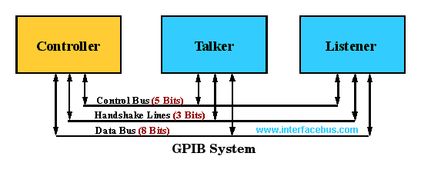
Pin # Signal names Signal Description Pin # Signal names Signal Description
1 DIO1 Data Input/Output Bit 1 13 DIO5 Data Input/Output Bit 5
2 DIO2 Data Input/Output Bit 2 14 DIO6 Data Input/Output Bit 6
3 DIO3 Data Input/Output Bit 3 15 DIO7 Data Input/Output Bit 7
4 DIO4 Data Input/Output Bit 4 16 DIO8 Data Input/Output Bit 8
5 EIO End-Or-Identify 17 REN Remote Enable
6 DAV Data Valid 18 Shield Ground (DAV)
7 NRFD Not Ready For Data 19 Shield Ground (NRFD)
8 NDAC Not Data Accepted 20 Shield Ground (NDAC)
9 IFC Interface Clear 21 Shield Ground (IFC)
10 SRQ Service Request 22 Shield Ground (SRQ)
11 ATN Attention 23 Shield Ground (ATN)
12 Shield Chassis Ground 24 Single GND Single Ground

GPIB On-Line Standards and Specifications Information

ANSI/IEEE 488.1 [IEC 60625-1] IEEE Standard Digital Interface for Programmable Instrumentation
Defines the Physical and Electrical layer, and signaling protocol.

ANSI/IEEE 488.2 IEEE Codes, Formats, Protocols, and Common Commands, and Standard Commands for Programmable Instruments

IEC/IEEE 60488-2 defines communication protocols for devices connected via IEEE 488 buses and common commands and characteristics useful in a wide range of instrument applications. It includes message-handling protocols, status reporting structures, and system configuration and synchronization protocols.

HS488 High-Speed GPIB Handshake Protocol Hand shake protocol, increases bus transfers to 8MBytes/s with other HS488 devices. NDAC is not required to Handshake, The Talker outputs data with DAV, waits then outputs new data with DAV without NDAC occurring.

SCPI Standard Commands for Programmable Instruments Defines a programming language for Instruments

IEEE488 Bus Interface IC Manufacturers

Standard TTL levels (2.0v/0.8v) @ 5.2mA source / 48mA sink, Totem Pole, Open Collector and Tristate devices are used with IEEE488.
Open Collector: SRQ, NRFD, NDAC
Open Collector or Tristate: ATN, IFC, REN, EOI, DAV.

MC3446; Quadruple Bus Transceiver [IEEE Standard 488 Compliant], 16-pin DIP [Obsolete part].
MC3447; Bidirectional Instrumentation Bus [GPIB] Transceiver, 24-pin DIP [Obsolete part].
TI {Controller TMS9914A-Transceiver, 75xx160/161/162}
Texas Instruments: DS75160A,DS75161A

There is not much special about driving over a IEEE488 bus, the original interface ICs were just normal TTL devices.
The Octal Transceiver 74F588 was used in many applications.

IEEE-STD-488 I/O Characteristics
Single Type Digital Value
Input Voltage High: VIH = 3.4 volts typical, 2.4 volts minimum
Input Voltage Low: VIL = 0.22 volts typical, 0.4 volts maximum
Input Current High: IIH = 2.5mA maximum
Input Current Low: VIL = -3.2mA maximum
Output Voltage High: VOH = 3.4 volts typical, 2.5 volts minimum
Output Voltage Low: VOL = 0.22 volts typical, 0.5 volts maximum
Output Current High: IOH = -5.2mA maximum
Output Current Low: IOL = 48mA maximum

IEEE488 Data Bus Transfer Timing
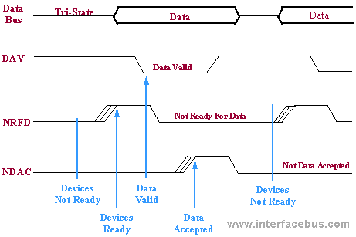

The IEEE488 bus operates at the speed of the slowest device, all devices have to be ready before operation begins.
Signals are active low. Data is transferred asynchronous, using the Handshake lines instead of a clock.
Only Parallel Polling does not use the Handshake, all other transfers use Hand-shaking.

HS488 High-Speed GPIB Handshake Protocol Hand shake protocol [not shown above], increases bus transfers to 8MBytes/s with other HS488 devices.
NDAC is not required to Handshake, the Talker outputs data with DAV, waits then outputs new data with DAV without NDAC occurring.

GPIB Cable Assemblies
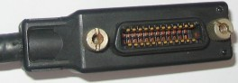
Connector Type: (The connector pin-outs differ) ....
IEEE488/ANSI MC1.1; 24 pins, accepts a ribbon cable. ....
IEC 625-1, MIL-C-24308; 25 pins
Connectors are tested to MIL-STD-202E (Environmental).

IEEE488 has a Maximum cable length of 20 meters, or 2 meters per device - which ever is less.
IEEE488 devices may be connected in either a Star or Linear fashion [Device-to-Device].

GPIB Cable Manufacturers
Belden
Keithley {Single/Double shielded GPIB Cables, IEEE-488 to Centronics cable adapter}
INES Test and Measurement
Normal cable lengths; 0.5 meters, 1m, 2m, and 4 meters.

Metric threads are Black, English threads are Silver; the two will not mate together.

GPIB Pinout Table
GPIB Pin No | GPIB Line Name | GPIB Abbreviation
1 | Data Input / Output 1 | DIO1
2 | Data Input / Output 2 | DIO2
3 | Data Input / Output 3 | DIO3
4 | Data Input / Output 4 | DIO4
5 | End or Identify | EOI
6 | Data Valid | DAV
7 | Not Ready For Data | NRFD
8 | Not Data Accepted | NDAC
9 | Interface Clear | IFC
10 | Service Request | SRQ
11 | Attention | ATN
12 | Shield (Connected to Earth)
13 | Data Input / Output 5 | DIO5
14 | Data Input / Output 6 | DIO6
15 | Data Input / Output 7 | DIO7
16 | Data Input / Output 8 | DIO8
17 | Remote Enable | REN
18 | Twisted pair with pin 6
19 | Twisted pair with pin 7
20 | Twisted pair with pin 8
21 | Twisted pair with pin 9
22 | Twisted pair with pin 10
23 | Twisted pair with pin 11
24 | Signal Ground

Cable GPIB
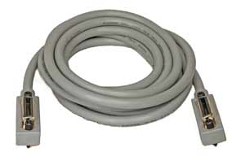Illustration 1: Cable GPIB/IEEE
Detalles
24 conductores de pares entorchados.
Braid shield (apantallado).
Conector Amphenol tipo 57, estilo Centronics, de 24 pines macho a hembra, apilables para facilitar el encadenaiento.
Restricciones del cable

GPIB Cabling Restrictions
Parameter | Details
Maximum number of instruments | 15
Maximum bus length | 20 metres
Max distance between instruments | 2 metres average, 4 metres maximum in any instance
Configurations | Star or linear or any combination

Conector GPIB

Conector amphenol tipo 57 de 24 pines se usa como el principal estándar para cables GPIB, aunque se han usado los tipos D y otros formatos. Consiste en una caja extruida metálica en forma de D que provee rigidez mecanica y ma ntiene en su lugar el plastico aislante interno, el cual mantiene los contactos individuales internos en su lugar.
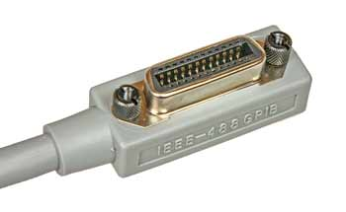Illustration 2: Conectro GPIB / IEEE 488
El conector tiene dos usos principales:
Como equipo: es de tipo hembra. Como cable emplea un conector macho en un arreglo de espalda con espalda permitiendo que múltiples cables sean colocado en forma apilada.
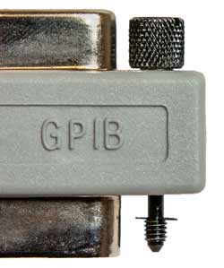Illustration 3: Seguros del conector
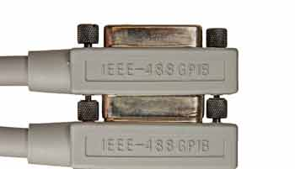Illustration 4: GPIB / IEEE 488 apilado de conectores

